

**Code: <*xxx*>**

# Table Of Contents

Dynamic Collections 1

Table Of Contents 2

About This Document 3

Glossary 3

Progress/History 3

Abstract 3

Part A: Concept & Basic Design 4

Stakeholders 4

Goals 4

Requirements 4

Open Issues/Known Issues/Limitations 5

Process Flows/Use cases 5

Entity Relationships & Definitions 5

External Systems 6

User Interface / Forms 6

Risks 7

Project Scope 7

Maintenance 7

Assessment 7

Work Item List 7

Related Documents 8

Sign Off For Part A 9

Part B: Technical Design 10

Code Review 10

Unit Tests 10

Technical Design Considerations 10

Technologies Used 10

Application Architecture 10

Database Table Definitions 10

??? 10

# About This Document

This document describes the concept and design of an application most likely related to EQUELLA. It will be used by TLEI during the planning phase of a project to document all conceptual and design-related decisions, and must be signed at the end of the planning phase (before development begins) by both TLEI, relevant service providers and the target company (for customer functionality if applicable).

For a detailed description how this document fits into TLEI’s web development methodology, please refer to the document *TLEI Web Development Methodology.doc*.

Project Managers, Business Analysts, Designers and Developers (limited extent) should be responsible for completing Part A (Concept & Basic Design) of this document and Technical Staff are responsible for completing Part B (Technical Design).Part A should contain enough detail to allow Part B to be completed in sufficient detail.

# Glossary

|  |  |
| --- | --- |
| **Term** | **Definition** |
| Dynamic Collection | A new type of EQUELLA entity that represents a set of items that may span across multiple Collections or Schemas. The set of Items are determined from search and filtering parameters, essentially the same as a hierarchy topic. |

# Progress/History

|  |  |  |  |
| --- | --- | --- | --- |
| **Version** | **Reason for Modification** | **Name** | **Date** |
| 1.0 | Initial Creation | Nick Read | 27 March 2009 |
|  |  |  |  |
|  |  |  |  |

# Abstract

EQUELLA provides an OAI-PMH endpoint such that its metadata can be harvested by third-party services. This functionality maps each EQUELLA Collection searchable by guests to an OAI Set.

Royal Holloway University of London have requested for more flexibility, allowing them to define OAI Sets that may map to more than one Collection, or only to certain items in a Collection. They have also asked for Collections to be dynamic, so that the number of Collections may change depending on what content is contained in EQUELLA at that time.

# Part A: Concept & Basic Design

## Stakeholders

Who is affected by or affecting the Project. Is this project sponsored development work? If so, who are the external stakeholders?

|  |  |
| --- | --- |
| **Name** | **Position** |
|  |  |
|  |  |
|  |  |

## Goals

This is a list of victory conditions, describing what the end results will be. The goals should be framed against 4 basic criteria:

1. Protecting our base
   1. Our reputation in the market
   2. Our current client base
2. Winning more clients
3. Earning more income per client
4. Doing this efficiently and constraining costs

|  |  |  |
| --- | --- | --- |
| **ID** | **Goal** | **Importance to reach this goal\*** |
| G01 | Providing a more flexible OAI solution for EQUELLA. Gary Pesticcio has indicated that this is very important to securing further clients that use EQUELLA as a Research Repository. | 1 |
| G02 | Match the functionality provided by the EPrints system | 2 |
| G03 | Allow for the functionality to be utilized in other services types, not just OAI. | 3 |

* 1=High, 2=Medium, 3=Low

## Requirements

This is what the solution should fulfill. The priority column can be used to decide if the project needs to be completed in stages.

|  |  |  |
| --- | --- | --- |
| **ID** | **Functional Requirements** | **Priority to meet this requirement\*** |
| FR01 | Allow for new OAI Sets to be defined. | 1 |
| FR02 | OAI Sets should be filterable by Collection and Schema, similar to the functionality provided by Hierarchy Topics. | 1 |
| FR03 | Allow for “virtual” OAI Sets to be created for each value in a metadata field, similar to EPrints functionality. | 2 |
| FR04 | The new entity for the OAI Sets should provide the same abilities as other Base Entities, including the standard security privileges for usage and managing. This includes providing the same security configuration tab that other Base Entity editors use. | 2 |
| **ID** | **Non-Functional Requirements** (e.g. usability, reliability, performance, security, portability) | **Priority to meet this requirement\*** |
| NFR01 | The new functionality should be exported on a new OAI endpoint, leaving the existing OAI functionality intact. This is to prevent disruptions or configuration changes for existing customers. | 1 |

* 1=High, 2=Medium, 3=Low

## Open Issues/Known Issues/Limitations

The following issues must be clarified before any development can start.

|  |  |  |  |
| --- | --- | --- | --- |
| **ID** | **Issue** | **How do we resolve this (if at all)?** | **Importance to resolve this issue\*** |
| I01 |  |  |  |

* 1=High, 2=Medium, 3=Low

## Process Flows/Use cases

The following describes involved process flows. Use cases can also be used as a basis for test case scenarios.

### Use Case 1: OAI-PMH Consumers

OAI-PMH is an open standard, therefore consumers should be able to interface directly with this new endpoint in the same manner they would with the original endpoint, or any other OAI service for that matter.

### User Case 2: OAI Set Creation - Basic

An EQUELLA administrator wishes to create a new OAI Set that contains Items from two different Collections with certain values for metadata fields.

They load the Administration Console and choose to add a new Dynamic Collection. They specify a name for the entity that they expect to be visible as the OAI Set name to OAI consumers. They select that the Dynamic Collection should be exported as an OAI Set. They select the Collections they wish to filter Items down, and find the interface familiar as it is the same as the Item Filtering tab in Hierarchy Topics.

They choose to save the Dynamic Collection and expect the new OAI Set to be available immediately to OAI consumers.

### User Case 3: OAI Set Creation – Dynamic Filtering

An EQUELLA repository exists in a library with hundreds of thousands of Items, each representing a book record that has a publisher field. The library wants to make an OAI Set available for each publisher, but there are hundreds of these. The list of publishers can also grow or shrink depending on what book records are in the repository.

An administrator loads the Administration Console and chooses to add a new Dynamic Collection. They specify a name of “Publisher” and then select that the Dynamic Collection should be exported as an OAI Set. They choose the “Dynamic Filtering” tab and choose the enabled the feature. They select the XPath to the publisher field and then choose to use the contributed items as the source of publisher values.

They save the Dynamic Collection and expect a new OAI Set for each value of the publisher field to be available immediately to OAI consumers. They have Items with a publisher of “Penguin Books”, so they expect an OAI Set to be “Publisher = Penguin Books”. Listing the OAI records of this Set, it is expected that only items with a publisher field of “Penguin Books” are shown.

### User Case 4: OAI Set Creation – Combination of Basic and Dynamic Filtering

The administrator wants to use Dynamic Filtering over two Collections of the same Schema, but also wants to restrict to Items that have a value of “true” in a field called “public”.

They load the Administration Console and choose to add a new Dynamic Collection. They move to the Item Filtering tab, choose the Collections to restrict to, and add scripting to only choose Items where “public” is “true”. They then move to the Dynamic Filtering tab and perform further setup as required to generate many virtual OAI Sets.

They save the Dynamic Collection and expect their new OAI Sets to be available immediately. Several new OAI Sets are available, but as expected, only containing Items with a “public” field being “true” and are from either of the two Collections.

## User Interface / Forms

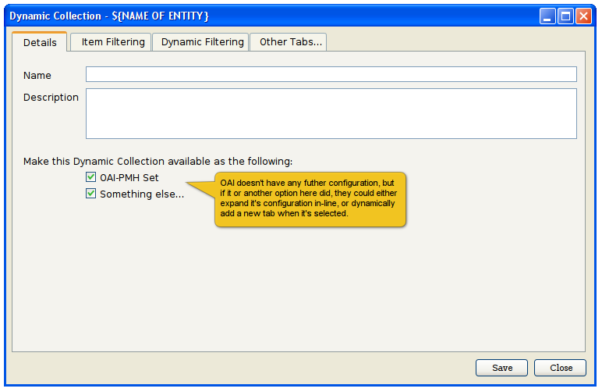

Figure : Basic tab to show that Dynamic Collections must choose to be exported via OAI-PMH

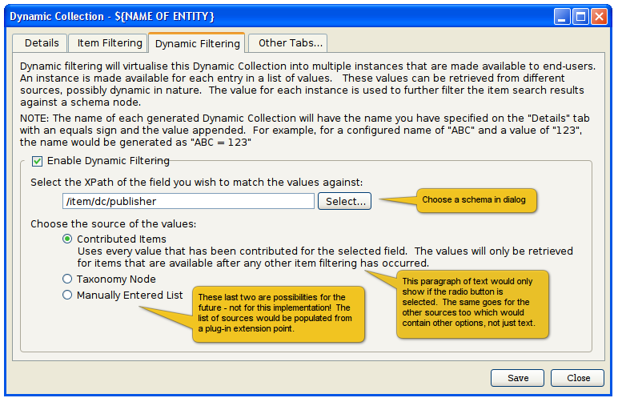

Figure : New tab to define Dynamic Filtering – See FR03 and UC3

## 

## Risks

We conceive the following risks for this project.

|  |  |  |  |
| --- | --- | --- | --- |
| **ID** | **Risk** | **How can we avoid this?** | **Importance to avoid this risk\*** |
| R01 | Disrupting existing OAI services | See NR01 | 1 |

* 1=High, 2=Medium, 3=Low

## Project Scope

The following will **not** be part of the project.

* Configuration of the OAI Identifier is being implemented as a different project.

## Maintenance

The following people will initially be responsible for the tasks listed.

|  |  |  |  |
| --- | --- | --- | --- |
| **ID** | **Maintenance Job** | **Responsible Person** | **Backup Person** |
| M01 |  |  |  |

## Assessment

We propose the following methods for checking if the project was a success. These measurements may correlate directly with the project goals but additional assessment methods may be applicable.

|  |  |  |  |
| --- | --- | --- | --- |
| **ID** | **Assessment method** | **What does this method measure?** | **Accuracy of measurement** |
| A01 |  |  |  |

## Work Item List

The following are estimates of the required amount of work and timelines. **This is very important when undertaking sponsored development work that is being done on a fixed budget!!**

|  |  |  |  |  |
| --- | --- | --- | --- | --- |
| **Task** | | **Responsible** | **Total Hours** | **Timeline** |
| **Planning** (e.g. Goal & Requirements Analysis, Process Flows/Use Case Definition, Entity Relationships & Definitions, User Interface/Forms Wireframes | | | | |
| ID |  |  |  |  |
|  |  |  |  |  |
| **Implementation** (e.g. creation of database tables and stored procedures, data import, generating mark-up, programming ) | | | | |
| ID |  |  |  |  |
|  |  |  |  |  |
| **Testing** | |  |  |  |
| ID |  |  |  |  |
|  |  |  |  |  |
| **Training & Documentation** | | | | |
| ID |  |  |  |  |
|  |  |  |  |  |
| **Deployment** | | | | |
| ID |  |  |  |  |
|  |  |  |  |  |
| **Total** | |  |  |  |

## Related Documents

The following resources are also important for this project.

# Sign Off For Part A

This document details what <***insert client name****>* expects and what TLEI should deliver. After reviewing this document, along with any related documentation, both groups should sign off before work begins.

**NOTE**: TLEI is only responsible for implementing what is included in this document and related documentation. Any feature or additional functionality not described in these documents must be separately assessed.

<***insert client name****>* **Sign Off**

This Concept & Design Document and the above listed related documentation accurately describe our requirements and contains all requirements we have for this phase of the project.

Client:

Date / Signature:

**Service Provider Sign Off**

This Concept & Design Document and the above listed related documentation contain enough information to enable us to implement the project. We guarantee that we will invest all our power to complete this project in the allotted time in accordance with the information presented in this documentation.

Service Provider Project Owner:

Date / Signature:

# Part B: Technical Design

## Code Review

Before you begin development, you should discuss your planned approach with another developer. This doesn’t need to be done formally but rather using an “over the shoulder” approach. Once you have finished coding you should step through your code with a **different** developer. This will improve general coding standards and is a good way to share and transfer knowledge.

|  |  |  |
| --- | --- | --- |
| **Coding Developer(s)** | **Reviewing Developer(s)** | **Date** |
| **Before Development Begins** | | |
|  |  |  |
| **After development complete (ask a different reviewing developer)** | | |
|  |  |  |

## Unit Tests

* We currently do not have a set of Unit Tests for our OAI-PMH endpoint, but it has previously been identified as a difficult area to manually test. It is strongly recommended that Unit Tests be created as part of this development.

## Technical Design Considerations

* Dynamic Collections should be a Base Entity
  + The editor should include the standard Security tab that other Base Entities do
* We should refactor out a lot of the existing code from the Hierarchy item filtering, both the server and client-side work.
  + The Item Filtering tab should be identical to the Hierarchy Topic editor’s.
  + The code for generating the search query based on the Item Filtering tab should be identical to that currently in the Hierarchy service (sans inheritance, as Dynamic Collections are flat and not hierarchical).